Instructions for filing an intervention to FERC:
Background:
- The Secure the Grid Coalition filed a Complaint on March 9th with FERC that argued: 1. The current NERC standard for GIC protection is inadequate (NERC TPL-007-4) and, 2. The electric utility industry must be incentivized by cost recovery to protect the grid from GIC to the Department of Energy recommendations,3 Congressional EMP Commission recommendations4, and the International Electrotechnical Commission (IEC) Standard5 and to avoid exceeding the IEEE 519 Standard6 due to GIC induced harmonics which is costing the U.S. economy billions of dollars each year.
- FERC opened a docket on this issue, which is Docket No. EL26‐49
- When someone intervenes on this docket, it tells FERC that there are interested parties and allows for those parties to comment on the matter. Thus we would really appreciate as many STG Coalition members possible file interventions.
- The deadline to file an intervention and/or Comment on this docket is 5:00 Eastern Time on March 30, 2026

How to File:
- Submit to FERC online HERE (See detailed instructions below) or
- Submit by mail:
Federal Energy Regulatory Commission
Debbie-Anne A. Reese, Secretary
ATTN: Docket No. EL26‐49‐000
888 First Street, NE
Washington, DC 20426

Detailed Onliner Filing Instructions:
- From the FERC Home Page, click on the icon on the left for FERC Online:
- You must have a FERC Online Account. If you don’t, register here: https://ferconline.ferc.gov/eRegistration.aspx
- If you are already registered, log in and click on eFiling.

To file a Motion to Intervene:
- You can file either ”doc-less” (all online) or select “Motion to Intervene” to upload a document. A motion to intervene puts you on the service list so you will be notified of filings.
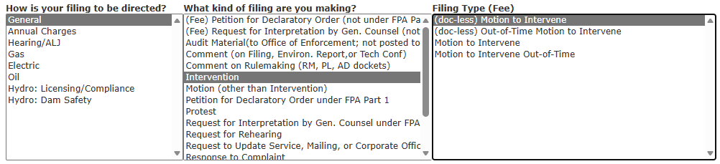

To file a comment:
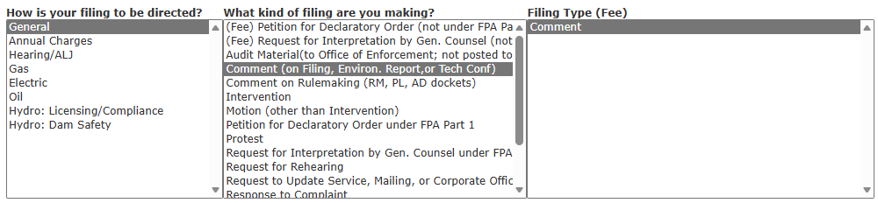
Note: If you are doing a Motion to Intervene and Comment, you can do it either from “Motion to Intervene” or from “Comment.”

- You can use the template below for your written comment
- The example text provided below can form a basis for your own arguments for more transparency.

UNITED STATES OF AMERICA
BEFORE THE
FEDERAL ENERGY REGULATORY COMMISSION

Complaint and Petition of the Center for Security )
Policy and the Secure the Grid Coalition to )
Authorize Cost Recovery for Utilities That Assess ) Docket No. EL26-49-000
And Protect the Electric Grid from GIC )
To the International Standard of 85 V/km )

Motion to Intervene and Comments of [NAME]
Submitted to FERC on [DATE]

I__ Your Name___, am a private citizen, and an electric utility ratepayer who would be adversely impacted by a loss of the electric grid due to solar weather or an attack by an adversary. I respectfully submit a Motion to Intervene and Comments on FERC Docket No. EL26-49 filed by the Secure the Grid Coalition.

My background is___ [provide background information about yourself and your company as it is relevant.

I represent _____[if you are a member of and/or represent any organizations, this is helpful to list]

Text of your comments.

Respectfully submitted by:
(insert signature below)

---------See filing instructions below-------------------
- Go back to the FERC website and go to the FERC Online section
  - https://www.ferc.gov/docs-filing/ferconline.asp
  - Create an account and/or Login with your credentials
  - Click on “eFiling”
  - Go to: General —> Intervention —> Motion to Intervene (then click next)
    - On the next screen enter docket number: EL26-49
    - Then follow the prompts to upload your document.
  - Attach the PDF (Filing is free.)
  - See screenshots below:
